Manual

I - Getting started

Overview
ZeNeuSound is a tool to sonify neural imaging data. It uses a system of regions of interest (ROI) on which parameters are computed then used to control the outcoming sound. Currently up to 200 ROIs can be used at the same time.
The principle of the sonification is to let each ROI play a single note, which amplitude is driven by the mean value of the ROI (« Signal ») at the current frame. The ROIs are put in clusters, defined by their color and number, each ROIs in a given cluster play the same note. The allocations of the clusters, and associated notes notes is left to the user, and another cluster related parameter (mean value, etc) can be mapped to the brightness of the sound.
The data used for the sonification are the mean values on each ROIs over time computed with FIJI and treated with the provided Matlab scripts, and the ROI set from FIJI treated with the matlab script.
Thus the patcher requires :
- The data
- The ROIs locations
- The notes attributed to each cluster
- The video associated with the data
You can freely allocate ROIs to up to nine clusters, set notes for the clusters, change and save the mapping, and select the sound produced by the different clusters.
To lauch the program, double click on zebraSound.maxproj. At the start, the program loads a default set of data with the associated clusters.

Installation
The software runs with Max/MSP (Cycling `74) and can be downloaded here. Max/MSP is a commercial software, however a trial version allows you to run patchers and to save changes for up to 31 days.
To install the sofware unzip the .zip file in a new folder. It contains all the files needed to lauch the program.
The other folder contains the scripts needed to treat the data in order to use them with Max/MSP. There are three scrpts : exportClusters.m (cluster file), exportROI_txt.m (ROI file) and read_resultsImageJ.m (data file). Credit for the readImageJROI.m function goes to Dylan Muir.
A default data set is included : mean_raw.txt (data) and roitext.txt (ROI location on the video), as well as few note set.

II - The interface
The interface is built around two panels, the Main panel from which you can access the main information and interactions and the Mapping panel to modify the mapping,

Main panel
The Main panel is the main interface, where you can access the different panels and the main options to control the sonification.
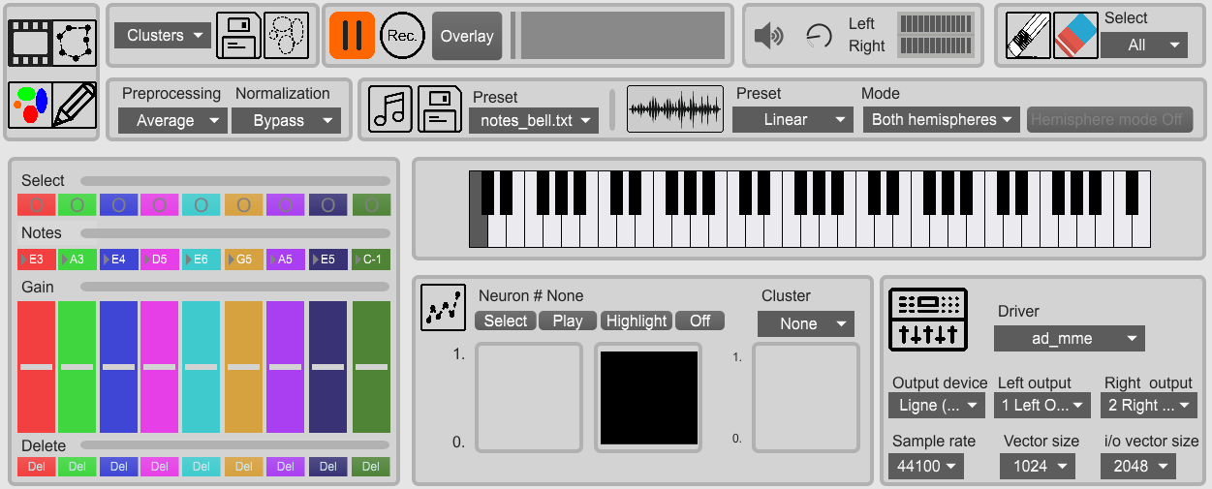Figure 1: Main panel
This is divided into several areas : Input files, Clusters, Video, sound. Tools, data processing, sound and mapping, clusters interface, note selection, graph section and driver section.

1) Data
This section controls the data sets for sonification.
-  : load video
- 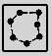 : load ROI set
- 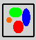 : load clusters set
-  : load set of fluorescence signals

2) Clusters
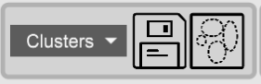Figure 2: Clusters section
This section allows to manage the three available sets of clusters. From left to right :
- The menu allows to switch cluster sets.
- Save current cluster set
- reset cluster sets

3) Video
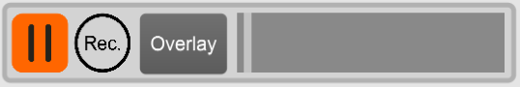
This section manage the video playback. From left to right :
- Play/pause
- When clicking record (rec) a recording of both audio and video begins. Another click ends the recording and save the file.
- Playback control

3) Sound
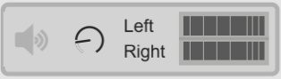Figure 3: sound interface
From left to right :
        - turn on/off the sound processing.
        - Volume control
        - Left/Right output vu-meter

4) Sonification control
This section controls the sonification : groups, notes, mapping, etc.
- Groups interface (fig 3) : the nine colored tracks contain the controls for the different groups. Each track contains, from top to bottom:
  - a slider to control the volume of the group
  - the note attributed to the group (can also be used to choose the note)
  - a select button to select or deselect the group
  - a Del button to delete the group
Load/write clusters : load a cluster file or write one on disk
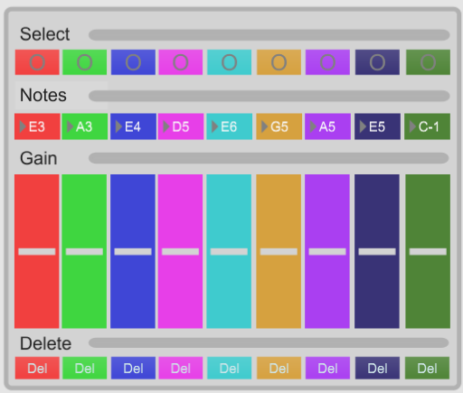Figure 4: clusters interface

5) Tools
The tools section allows to exclude neurons from the sonification, and to select which neurons to hear (plotted neurons only, plotted clusters only, all neurons). From left to right
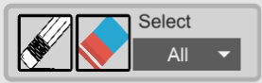Figure 5: tools section
- Enter del mode to exclude neurons from the sonification
- remove all neurons from the sonification
- menu to select which neurons to hear.

6) Processing section
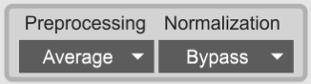Figure 6: processing section

This section allows too choose the preprocessing method (first menu) and the normalization method (second menu)

7) Graph section
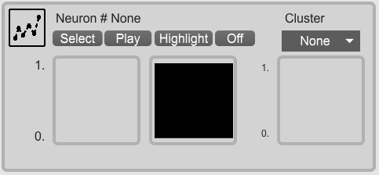Figure 7: graph section
This section allows to plot the normalized activity of a single neuron and the group parameter associated with a cluster. From left to right :
- graph panel
- select button : click the button then on the desired neuron to choose it.
- Play/pause button : play/pause the plotting
- hilight button : remind which neuron is beeing tracked
- off button : turn off the graph.
- Menu to select a cluster to plot.

8) Driver section
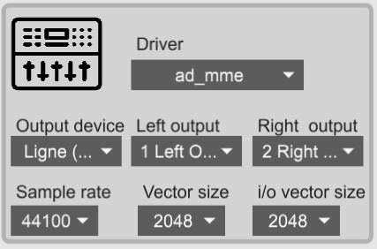
This section allows to set the audio parameter (advanced users).

Mapping panel
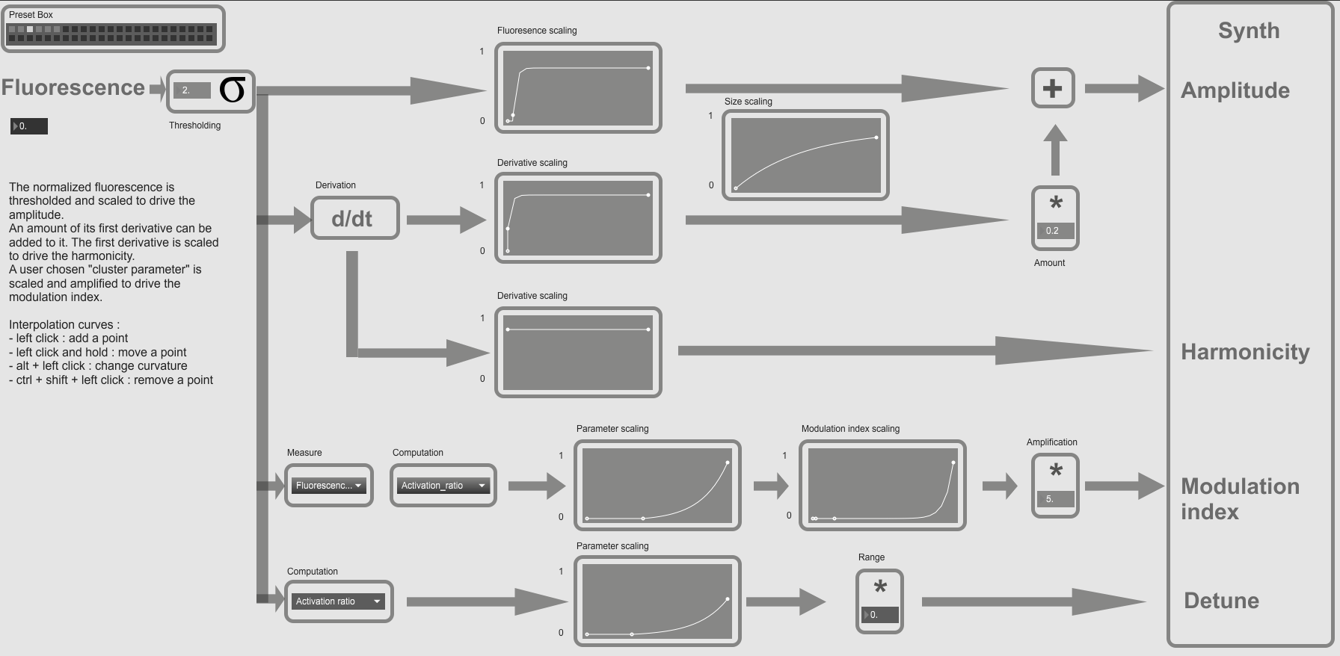Figure 8: Mapping panel
The Mapping panel allows you to control the mapping (i.e. adjust the parameters of the data to control the parameters of the sound), the scaling functions and the parameters used. You can access it by clicking on the Mapping button on the Main panel.
The panel is presented as a flow chart where you can follow the signal from the normalization to the synthesizer.
From top to bot you can find :
- the amplitude line
- the harmonicity line
- the modulation index line
- the detune line
We callthe incoming, processed and normalized signal.
All the curves on this panel are scaling curves which are used to scale the values. They make the coming value, the absissa, corresponds to the output value, the ordinate.
- Add a point : click
- remove a point : shift + click
- change curvature : ctrl + click
- move point : hold click
- Amplitude modulation line : this line shows the mapping of each ROIs signal to the amplitude of the sound signal.
  - The normalized signal is fed to the Threshold to only conserve the activated ROIs. The incoming signalis threshed with a value corresponding to the standard deviation of the signal multiplied by a coeficient. The number box allows you to set the coeficient.
  - The outcoming signal is scaled using a scaling curve to make the activation more easily perceived.
  - The signal is then Sharpened adding its derivative (d/dt). The number box allows to change the amount of derivative added. This is to enhance the perception of events in the datas set.

- Modulation index line : this line describes the mapping to the index modulation. The normalized signal runs through it.
  - Measure menu : which value is used for computation
      - activation value : the normalized signal is used.
      - Speed value : the derivative of the normalized signal is used

  - Computation menu : what parameter is computed
      - Average and average derivative: the mean value over the whole group (or its rate of change computed over three frames) which contains the ROI is mapped.
      - Activation ratio : the ratio between the number of activated ROIs (i.e the choosen measure is non zero) and the total number of ROIs in the group is mapped.
      - Activation ratio rate of change : the first derivative (computed over three frames) of the activation ratio is mapped.
  - The outcoming signal goes through two scaling curves.
- Detune line : this line describes the mapping to the detune effect between hemisphere. Based on the chosen parameter, neurons in the left hemisphere are pitched higher, and the ones in the right hemisphere are pitched lower.
  - Menu : select the parameter to use. The value used for synthesis is the absolute value of difference between left and right parameter.
  - Please note that the parameters are group based : the same detune will apply to each neurons in a given cluster and a given hemisphere.
- Presets : a set of parameter can be saved with shift + click on a square. Please keep in mind that an overwritten preset cannot be retrieved : overwriting a preset is permanent if the patcher is saved.

III – Interacting with the patcher
This section describes how to interact with the software : loading datasets, managing ROIs and groups, and modifying the mapping.

Loading different datasets
The first thing to do is to load a dataset which consist of:
- The data (fluorescence signals) to sonify
- The ROIs
- The associated video
- Cluster file (optional)
Please ensure all the loaded files have been processed with the provided Matlab script, as they need to be properly formatted to use on Max.
Procedure :.
- Load the video : click Load video button on the Main panel. The message read_new_video: [video] 1 appears in the console.
- Load the ROIs : click Load ROI file button on the Main panel. The message Read_new_ROI: bang
appears in the console
- Load the data : click Load data button on the Main panel. The message Read_new_data: bang should appear in the console.
- Choose the normalization and the processing : select the normalization and the processing to use with the normalization and processing menus on the main panel.
To load a cluster file click load cluster file button. This should be done after loading the ROIs.

Attributing groups, notes and using clusters
Every ROIs within a group produce a sound, an ROI not allocated to a group will not produce any sound.
The different ROIs are represented by colored dots on the display, the gray ones beeing the unallocated ROIs, and the colors represent the groups.
The basic idea is that when a group is selected every group related actions (such as adding an ROI, changing the note) are performed on this group. Up to nine groups can be used at the same time.
Adding an ROI to a group :
- Select the group by clicking on its select button [O] on the Sonification control section of the Main panel.
- Click on the circles you wish to assign to a group on the video. You should see the circles the color of you selected group.

Removing an ROI from a group :
- Enter Del mode clicking on the Del mode button on the Main panel.
- Click on the ROI to remove from a group on the video.

Setting a note for a group :
- Select the group by clicking on its select button on the Main panel.
- Click on the note on the piano on the Main panel.
You can save and load sets of notes with the Write notes and Read notes buttons on the Main panel.
Alternatively, you can set the note in the sonificaiton control section.

Monitoring signals :
- Click the Graphs button on the Main panel.
- Click the Select button and click on the ROI on the video, or select the group in the menu
- The same process applies to the graphs displayed on the main panel.
You can pause/unpause the writing by clicking on the on/off button.
Using clusters :
- Load the clusters : click Load cluster file on the Main panel.
When using cluster groups the groups you made are not overwritten, thus you can freely switch from one to another.

Modifying the mapping
You can modify the mapping using the Mapping panel. All the actions described on this part take place on this panel.

1) Mapping to the modulation index
On the bottom line of the flow chart you can change the mapping to the modulation index. This parameter of the FM synthesis is what makes a brighter, trumpet like sound. The default mapping is the mean speed of the whole group.
The two menu in the Modulation index mapping line allow you to select which parameter of the data set will drive the modulation index, and thus will have an effect of the outcoming sound.
The two scaling curves describe the relation between the chosen parameter and the modulation index and can be used , they make an input value correspond to an output value.
- The first curve scales the choosen parameter : it can be used as a threshold setting the curve at zero until a certain value, enhance the higher values or the lower values, or disable the parameter from going above a certain value.
- The second curve controles the scaling of the modulation index, it makes the scaled parameter value corresponds to a modulation index value.

2) Mapping to the amplitude
The value of the signal of the ROI is used to control the amplitude, thus the loudness of the outcoming sound. The signal goes through a discrimination, a sharpening and a scaling curve.
The threshold sets the values to 0 when the signal is under a threshold value. This threshold is the standard deviation of the ROI’s multiplied by a coefficient, set with the number box. The purpose is to exclude remaining noise and keep only the active part of the signal, when the ROI is considered active.
The outcoming signal is scaled using another scaling curve which is to also enhance the perception of the activation by obtaining a more « clicky » sound. Having a great value close to zero will result in increasing the variation in the sound, whereas a low value would smooth the transition.
The sharpening consists of adding its speed (first derivative) to the signal. It is used to enhance the perception of the moment when the ROI gets active by increasing the variations. The speed is scaled by the curve below. The number box is the amount of speed added to the signal.

3)Mapping to the detune
The detune effect is mapped to the difference in the group activity between the hemisphere.
The only quantity available for computation is the fluorescence. Two processing are avaiable : activation ratio and average in group.
The number box allows the user to set the range of variation : with f the note, a the coefficient, the new frequency varies between f-af and f+af .

Switching clusters
Three sets of clusters are implemented : clusters, handmade and left/right. Beside there default configuration, the three of them works on the same principle. Please note that when loading a set of clusters, it will overwrite the currently used set.
- Cluster is the default set. It is filled with a default set of clusters
- Handmade is empty by default
- Left/right is constituted of two clusters corresponding to the left and right hemisphere.
You can switch clusters by selecting the desired set in the menu, on the main panel.

III – Troobleshooting
First of all, if you have any sound issue please check your audio driver is up to date and your hardware is working fine. The patcher is CPU intensive, thus it is recommended to close any other application.

1) Sound issues
Bad sound, crackling sound
- Check the CPU usage from the audio status
  - go to option>audio status
  - check the CPU usage
  - if the cpu is at 100 %, decrease the sampling rate and increase both I/O vectors and signal vector size
- Try different Drivers and repeat the process if the problem is not solved
- If the problem persists and the cpu hits 100 % load, you can unselect some ROIs to reduce the amount of audio processing.

No sound
- Check whether audio is ON: the DSP button on the Main panel must be highlighted.
- In the audio status, check whether the correct output Device (i.e. the output of your computer or sound card) is selected.
- Check whether ROIs are allocated to groups : an unallocated ROI will not produce any sound.
- Check whether your data has been loaded : the message « Read_new_data» should have appeared in the console.
- Check whether the data has been processed : based on the selected normalization and treatment two messages should have appeared in the console, if they have not, relaunch the normalization or restart Max (especially for the running average) :
  - normalized_by_[method]
  - [method]_preprocessed

Some Rois do not produce sound
- Reload the ROI set.
- Lower the standard deviation coefficient in the Mapping panel.
- Move the scaling curve on the top line of the Mapping panel to the right.

2) Video issues
No video
- Make sure the video rendering is enabled : the video rendering button on the Main panel have to be highlighted.
- Check the video was successfully loaded. The message « read [video name] 1 » should have appeared in the console.
- Reset the patcher

Strange ROI placement
- Reload the video.
- Reload the ROIs.
- Reset the patcher

Slow video/bad synchronisation between video and sound
- Go to option>audio status.
- Turn down Sampling rate.
- Enable Scheduler in Overdrive

3) Known issues
- Overlay will not appear/no data are loaded on startup :
  - click reset patcher
- Before any changes in the mapping, please Turn the volume down.

https://github.com/DylanMuir/ReadImageJROI

